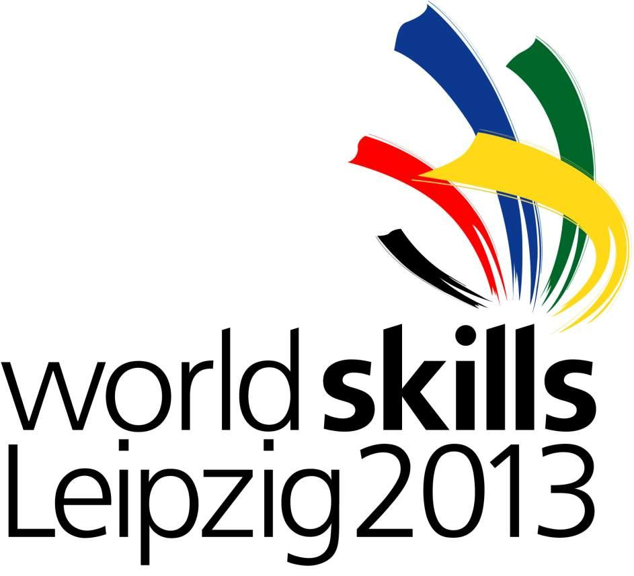
Registration form for the conference on

Green Industrial Skills for Sustainable Development
Risks and Challenges for Least Developed Countries
1 July 2013, Leipzig/Germany

on the occasion of the
42nd WorldSkills Competition 2013, 2 – 7 July 2013

Please send this response letter by 15 March 2013 to h.alam@unido.org
______________________________________________

I will attend the conference “Green Industrial Skills for Sustainable Development” on Monday, 1 July 2013

Name: ______________________________________________
Position: ______________________________________________
Organization: ______________________________________________
Country: ______________________________________________
Contact/Email: ______________________________________________

Additionally, I would like to be registered to:

Reception at Mayor of Leipzig’s Office, 1 July 2013, 7 PM

Industrial site visits on 2 July 2013, AM until the early afternoon

Observing participation at 42nd WorldSkills Competition, including
Opening & Closing Ceremony (2 – 7 July 2013)

Guided tour at WorldSkills Competition 2013, 3 July 2013, AM

OR

None of the above additional events

